**Forex & Currency Mega-Trades**

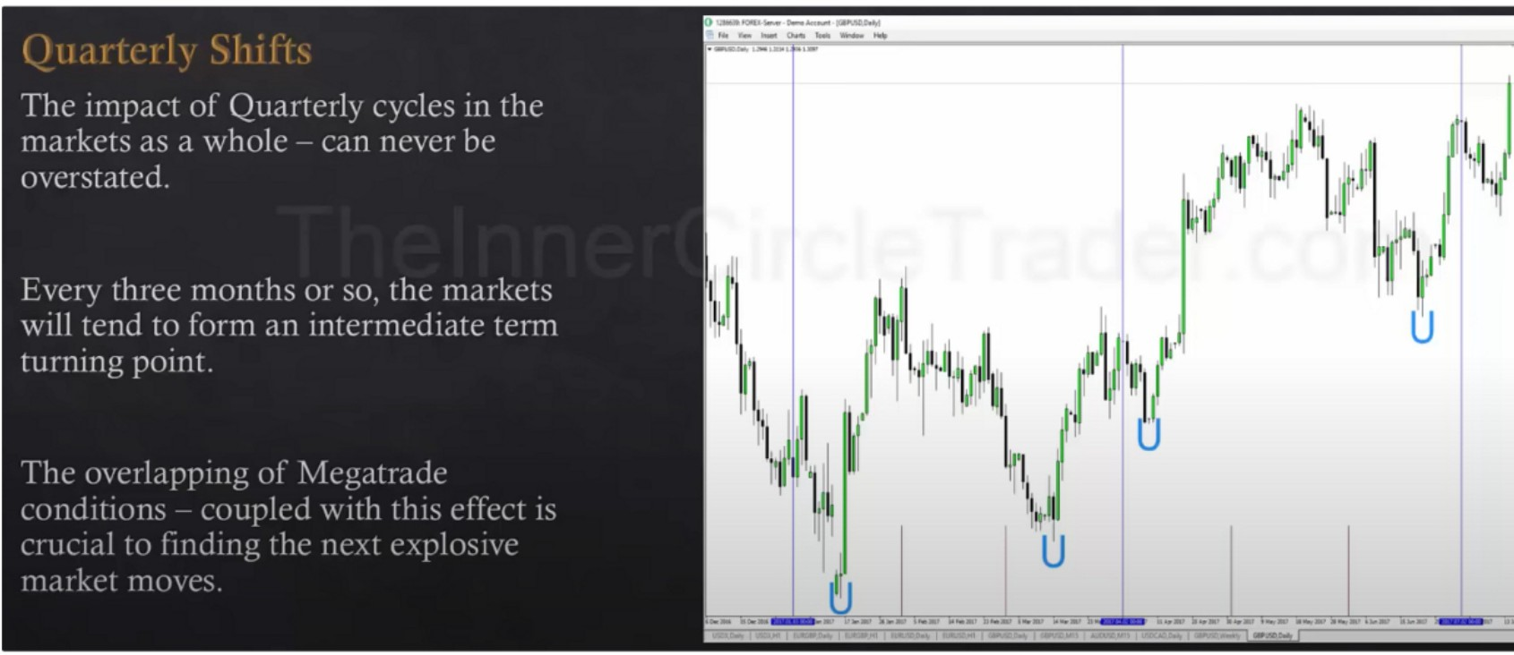

Megatrades are in between a swing trade and position trade

Combine institutional orderflow wiht quarterly shifts to see the quarterly shifts happen and confirm them

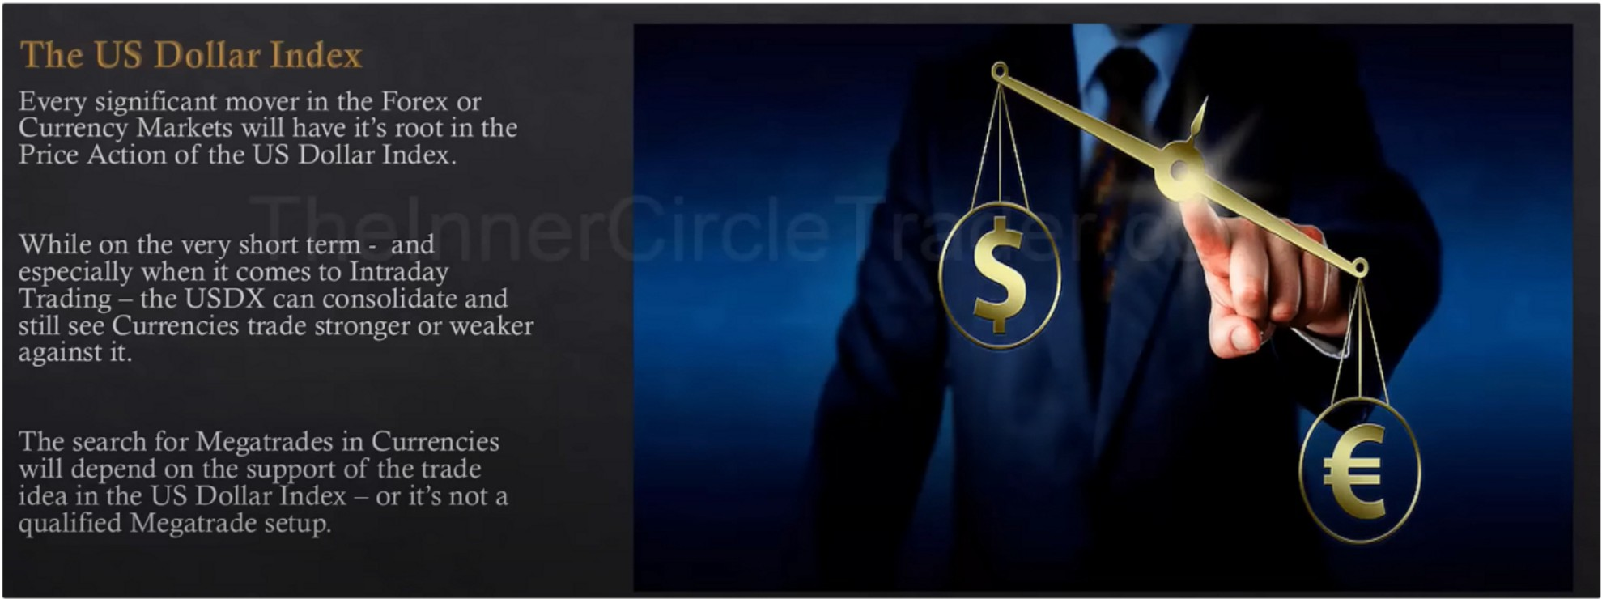

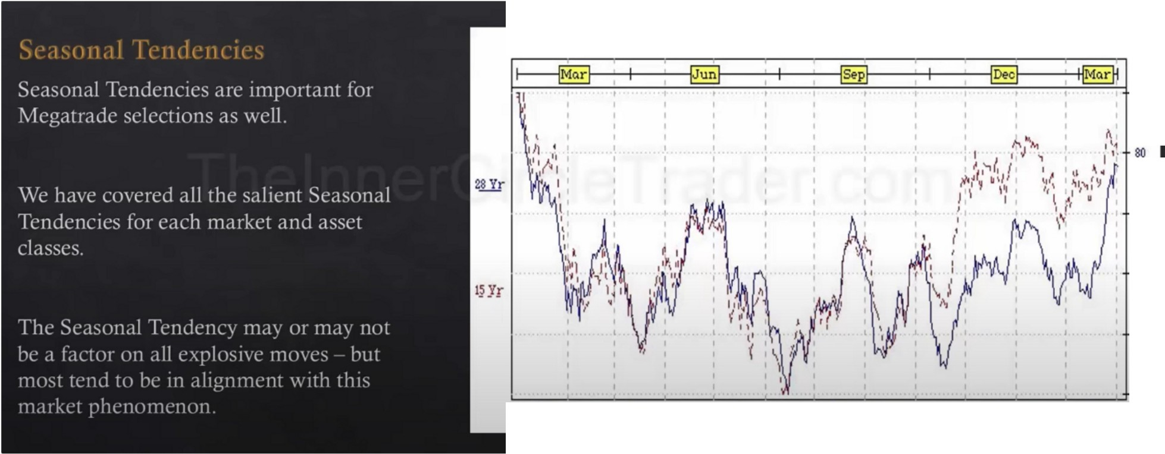

**Br-itish Pound(CME) 28 Yeal" Seasona.1(1975-2002)**

100

**60**

{0

**20**

**Jan Feb Mar Apr May Jun Jul Aug Sep Oct Nov Dec**

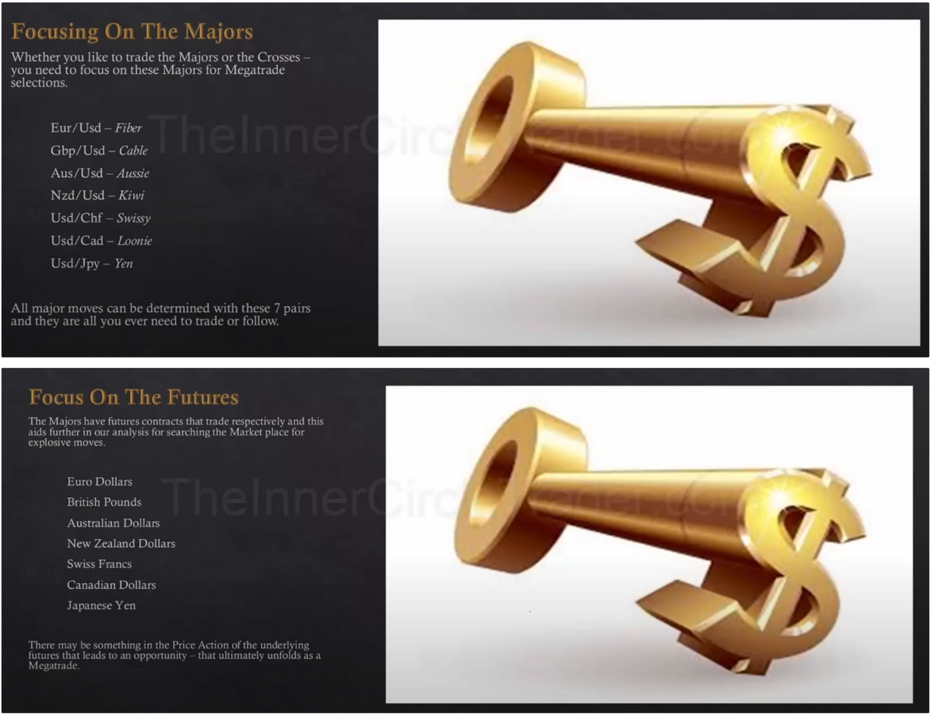

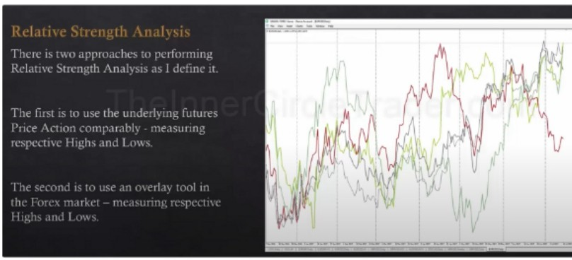

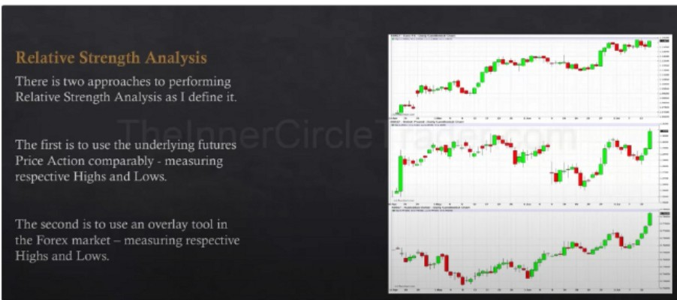

Focus on the markets that have a willingness to go higher and have higher lows, so the lows are holding and they should break highs in the form of premium arrays

Some will fail to break premium arrays, you want to cross those individiuals out Weak dollar is expected then we look for higher lows in the other currencies

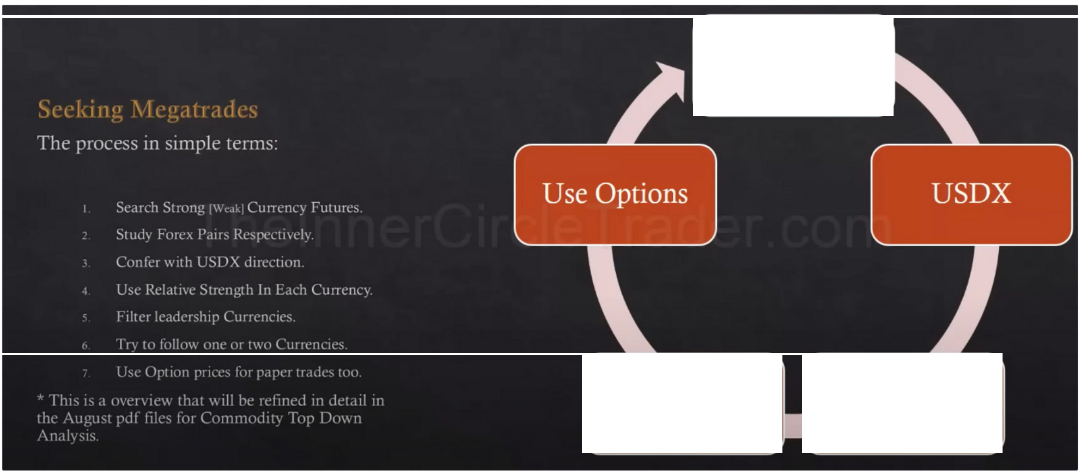

Institutional

Order Flow?

|  |  |  |  |
| --- | --- | --- | --- |
|  | Two Currency Leaders | Relative Strength |  |
|  | A6U17 • Australian Dollar. Daily Candlestick Chart  a Op:0.77230, H<0.78280, Lo:O.mJO,ct0.78170 |  | 0.78500 |
|  |  |  | **Em**  0.78000 |
|  |  |  | 0.77500 |
|  |  |  | 0.77000 |
|  |  |  | 0.76500 |
|  |  |  | 0.76000 |
|  |  |  | 0.75500 |
|  |  |  | 0.75000 |
|  |  |  | 0.74500 |
|  |  |  | 0.74000 |
|  |  |  | 0.73500 |
| 0 7JOOO  **13Apr 19 24 llloy 4 9** 12 17 **22 25 llun 6 9 14 19 22** 27 **3.Jul** 7 12 | | | |

Looking very strong

|  |  |  |  |  |  |  |
| --- | --- | --- | --- | --- | --- | --- |
| a Op | :1.14380 | Hi:1 | 15095 | Lo | :l!4290 | ,Ctl!5040 |
| **'1** ++•t | | | | | | |

Relatively strong

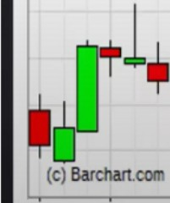

E6Ul7 • Euro FX • Daily Candlestick Chart

, . ,

1.15500

**!ID**

1.14500 l!4000 1.13500 l.lJOOO 1.12500

1.12000

1.11500

1.11000 l!0500 1.10000

1.09500

1.09000

1.08500

1.08000

1.07500

1.07000

**llApr 19**

**24**

**IMly 4**

**9**

12

17

**22**

**25**

**!Jun 6**

**9**

**14**

**19**

22

27

**3Jul**

7

12

1.06500

B6Ul7 • British Pound • Daily Candlestick Chart

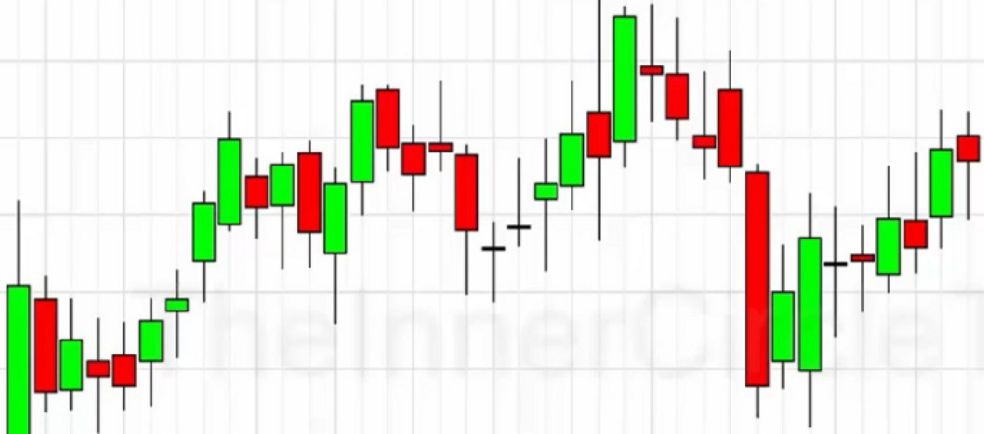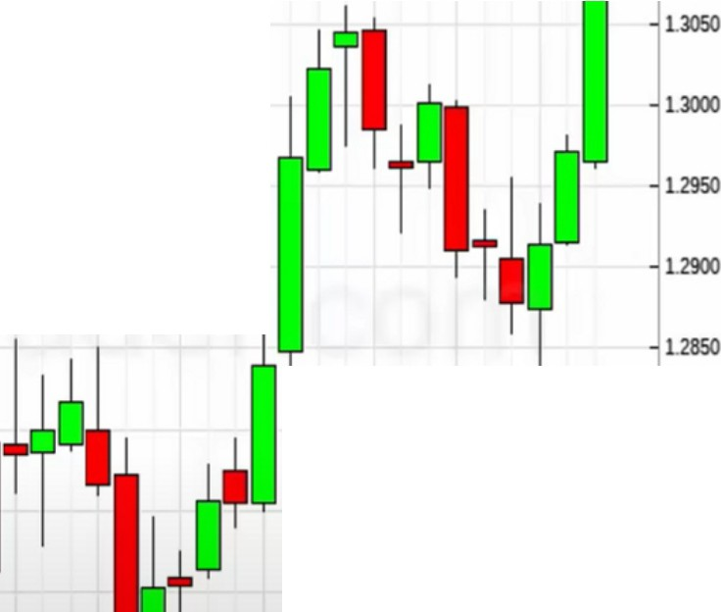

□Op:L-2965,-:1.3141,-Lo:1.296-2,Ctl.3-114 l.l!SO

**m**

1.2800

1.2750

1.2700

llApr 19 **24 lMly 4 9** 12 17 22 **25 !Jun 6** 9 14 19 22 27 **3Jul** 7 12

In a range, not a leader

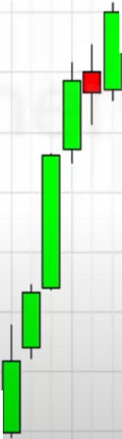

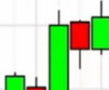Weak

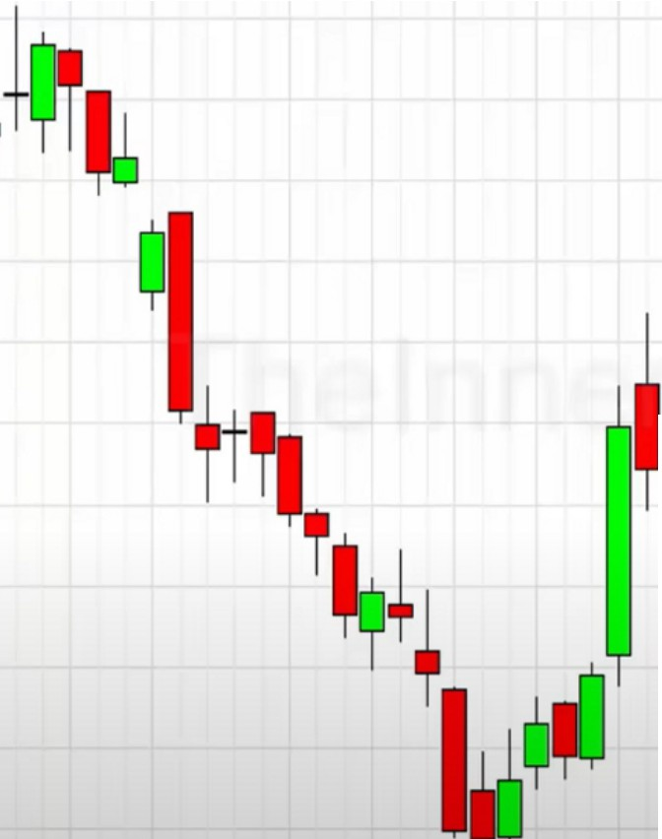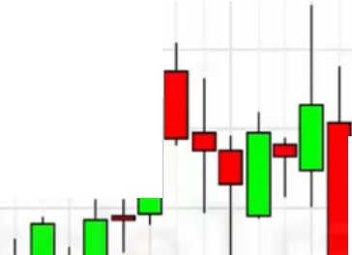

J6U17. Japanese Yen. Daily Candlestick Chart

c0p:o.ass 200,H<O=-=-c-893250,Lo -o.sa2100,=eto.890850, ,o.935000

0.930000

0.925000

0.91SOOO

++•+•

**t1¥1**' • =:

**lt**+

::

(c) Barchan.com

**llApr 19 24**

**lMly 4 9 12** 17 22 **2S 1.Jun 6 9 14** 19 22 27 **3.Jul** 7 12

S6U17 • Swiss Franc • Daily Candlestick Chart

□Op:L03800, HcL0-1260, Lo:L03490,CtL0-1160

== , L05500

t l+

**T** .+' ad

++1

I

I

'

l.

++;n

I :

L02500 L02000

f'+'tt•+?b +

L01500

LOIOOO

t

**at**

L00500

1.00000

-·

**13Apr 19**

I (c) Barchan.com

**24**

- 099500

**lMly 4 9 12** 17 22 2S **l.lun 6 9 14 19** 22 27 **3.Jul** 7 12

Relatively strong

|  |  |  |  |  |  |  |  |  |  |  |  |  |  |
| --- | --- | --- | --- | --- | --- | --- | --- | --- | --- | --- | --- | --- | --- |
| D6U17 • Canadian Dollar • Daily Candlestick Chart  =a 0p....,:0..,.._1864 5,Hi:0 .79 165 ,-Lo :o.1=ss=25....,,a:o .=79 11s o.19500 | | | | | | | | | | | | | |
|  |  |  |  |  |  |  |  |  |  |  |  |  | **mml** |
|  |  |  |  |  |  |  |  |  |  |  |  |  | 0.78500 |
|  |  |  |  |  |  |  |  |  |  |  |  |  | 0.78000  o.nsoo |
|  |  |  |  |  |  |  |  |  |  |  |  |  | 0.77000 |
|  |  |  |  |  |  |  |  |  |  |  |  |  | 0.76500 |
|  |  |  |  |  |  |  |  |  |  |  |  |  | 0.76000 |
|  |  |  |  |  |  |  |  |  |  |  |  |  | 0.75500 |
|  |  |  |  |  |  |  |  |  |  |  |  |  | 0.75000 |
|  |  |  |  |  |  |  |  |  |  |  |  |  | 0.74500 |
|  |  |  |  |  |  |  |  |  |  |  |  |  | 0.74000 |
|  |  |  |  |  |  |  |  |  |  |  |  |  | 0.73500 |
|  |  |  |  |  |  |  |  |  |  |  |  |  | 0.73000 |
| **13Apr 19** | **24** | **!Moy** | 12 | 17 | **22** | **25** | **I.Jun** | **14** | **19** | 22 | 27 | 12 |  |

Very strong

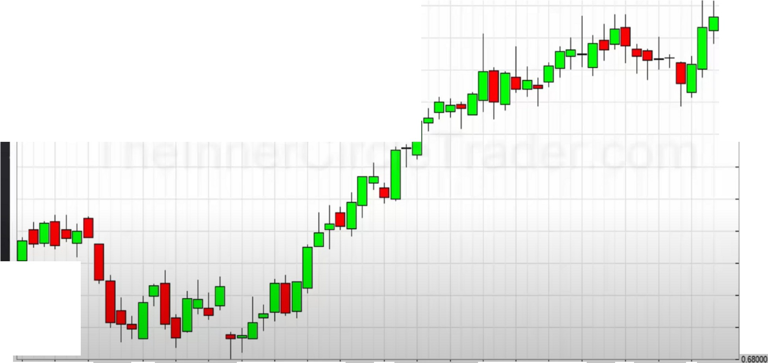

N6U17 • New Zealand Dollar • Daily Candlestick Chart

=c"'0p....,:o=.n=117"0,,,...H£0,.,,.73580==-,.,..Lo..,..:o729=20,...,,a:o,..,._=73330=c ,o.14000

0.73500

**lilmE**

0.73000

0.72500

0.72000

0.71500

0.71000

0.70500

0.70000

0.69500

0.69000

0.68500

(C) Barchan.com

13 **Apr** 19 24

**!Moy**

12

17

22

25

I.Jun

14

19

22

27

3 Jul

12

Strong, but bit rangey

Leadership are CAD and AUD and the YEN was a weak currency

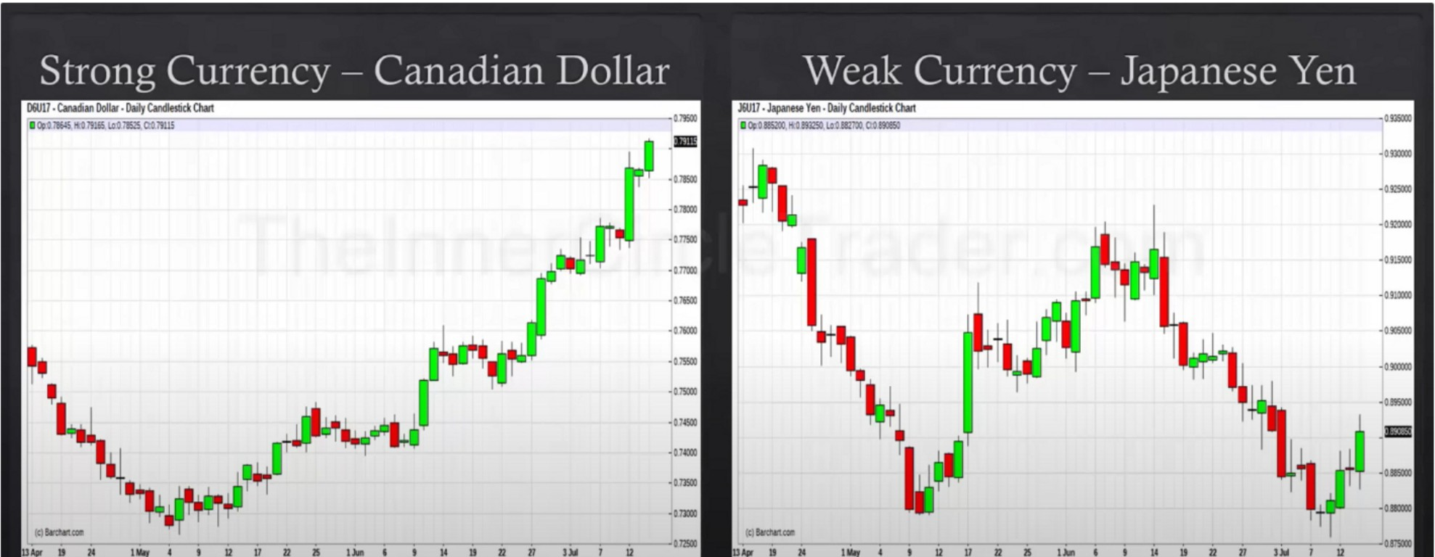

You can do longs on the futures market or you can use the forex market and this is how you do it, now you can look at CAD/JPY

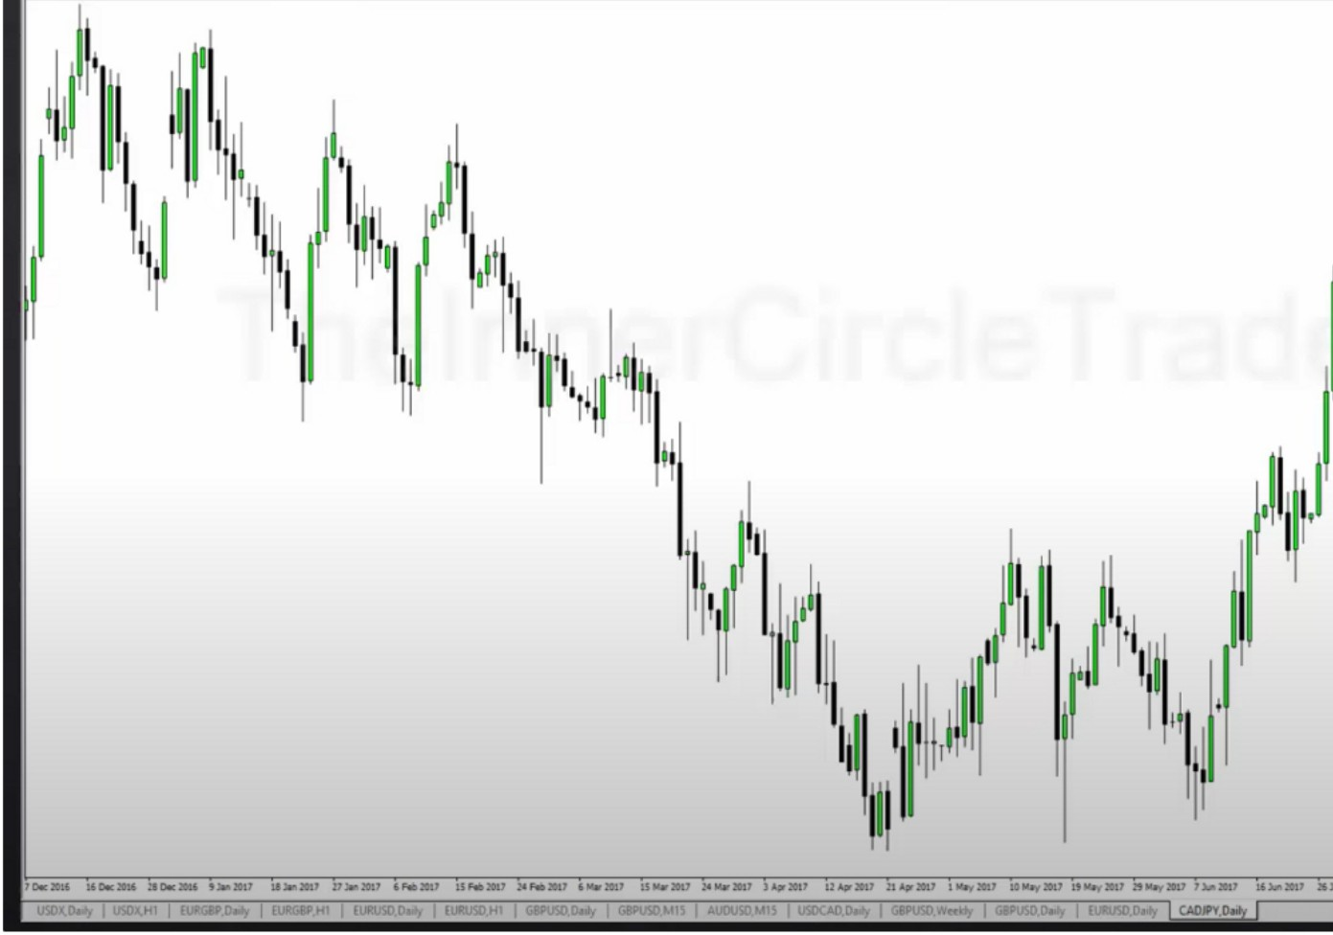

**0 \llM)lFOfl()(.S-,,,.,-DomoM-·[CAOJIY.o.t,t '- - 0-ST Help**

- *a* X

-

..

·Ii

,,I

*�*

*�*

...

-

You have to understand this to trade crosses

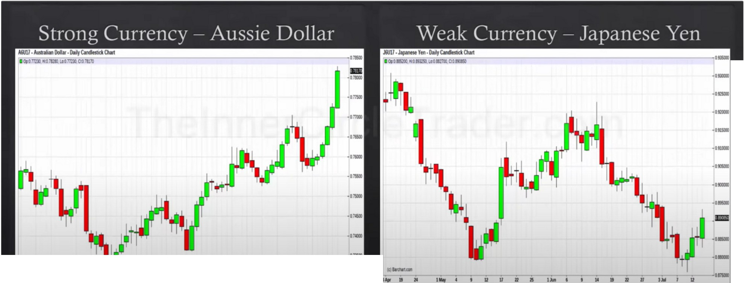

IJ"" II ,.

**llllor *4* t u 11 12 B** U• ' I w II **D J1 JM ' 11 -Ila**

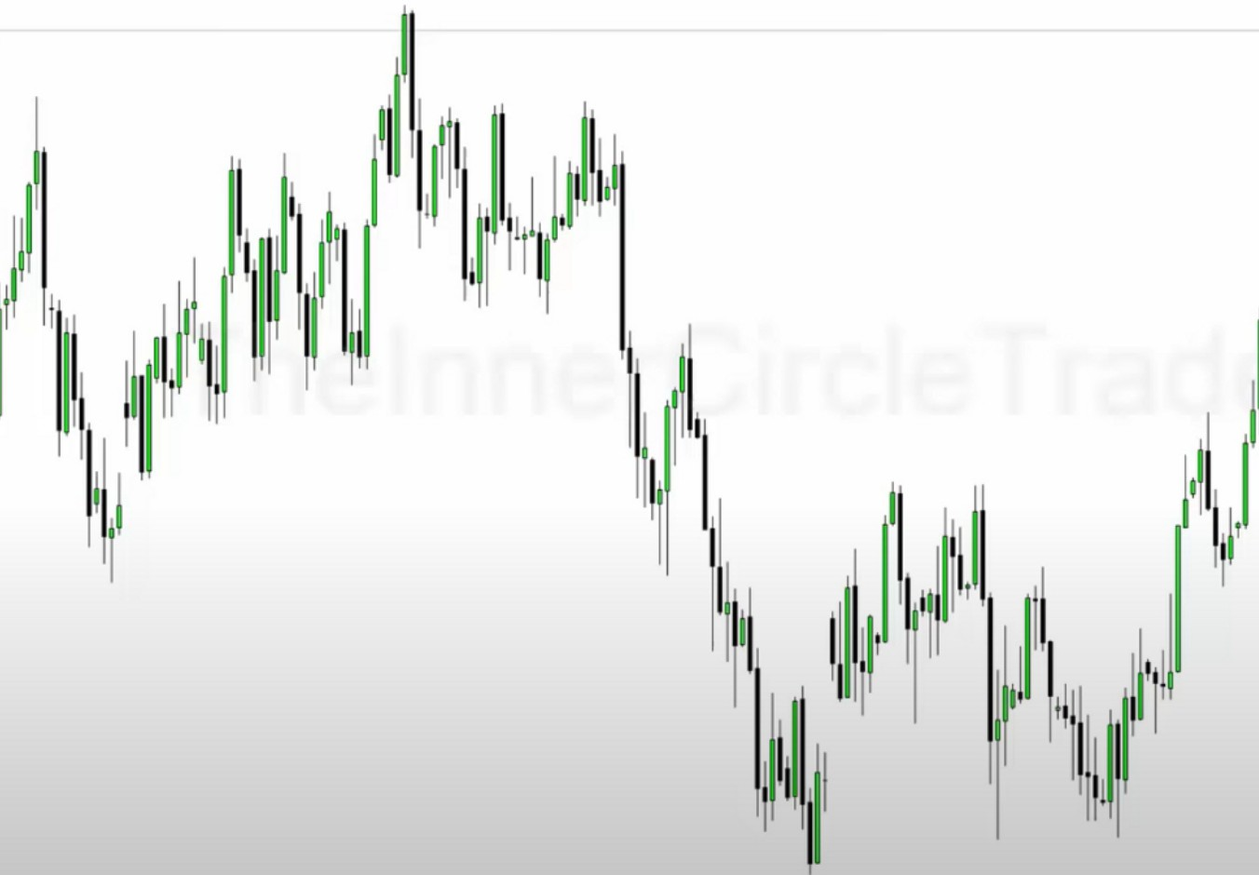

**"Jl.i.v...i....a-.,... ,,. ,**

I1

11 11

I

*)1*

.-..

....

-

-

-**k•**

-

-**OM**

.=.

..

.=..

**)Dlrl!DU IIDlralil •111r- 1i.oa11 11i.o•• Di.oat,** , ...... u ,,....., ,....., _II _, ,. ..........., **u....,** 21...., ,........ **,!I ,._., ,a,.., llll,o_,** ..... **IM:1111 l<IM_,**

.-..

,_,.,, **l.- Jl.--_H** ,_.,..,. **,.....,._n** ·- _,...,_1,,11; **MU** -_, _._ -• -•- ,_.., ....,,_ **1w AUD,,.,-.. -------**

- **0 X**

**0t2tlOlfOMll•S...w•DomoAcc-•[A .0-,I**

Big moves that are in a hurry This is how the banks do it

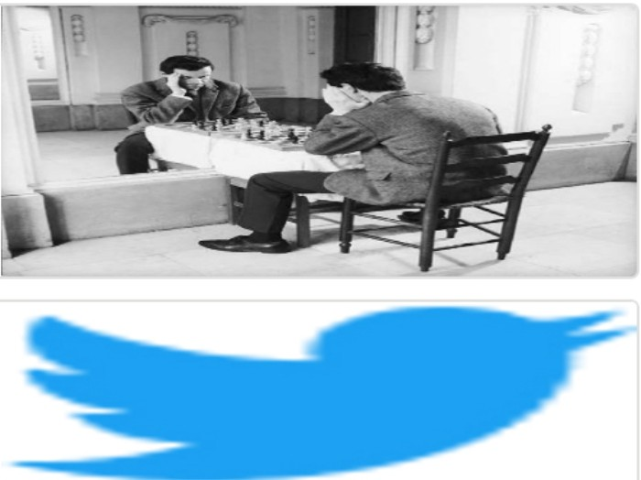Arjo I Twitter, lnstagram I Linktree

Linktree. Make your link do more.

, https://t.co/HhmmTN1fUI

JavaScript is not available.

***"'!I*** https://twitter.com/arjoio